
Date

<First last name>
<Address 1>
<Address 2>
<Suburb NSW 1234>

Dear <name>,

HAVE YOUR SAY
Improving road safety and calming traffic in Ashfield North and Croydon precinct

Council is developing a Local Area Traffic Management (LATM) plan to manage traffic and improve walking and cycling in the Ashfield North and Croydon precinct. This study area is bounded by Liverpool Road, Parramatta Road, Lang Street, Queen Street and Dickinson Avenue as detailed on the attached map.

The plan will aim to:
- Improve road safety for pedestrians, cyclists and motorists
- Calm traffic and improve access for pedestrians and cyclists
- Prioritise recommendations to improve amenity in the study area

How to have your say
Local knowledge of walking, cycling and driving in your neighbourhood is highly valuable to this work. You can provide feedback:
- Online at yoursay.innerwest.nsw.gov.au or scan the QR code below
- Email to shirley.rodriquez@innerwest.nsw.gov.au

- Post to c/o Shirley Rodriquez, Inner West Council, Po Box 14, Petersham NSW 2029
- Call us on 02 9392 5705

The last day to provide feedback is Sunday 9 March 2025.

Who should provide feedback?
We would like to hear from schools, residents, business owners, workers, and visitors to the area. The experiences of pedestrians, cyclists, motorists and other road users are all welcomed.

Enquiries
Please contact Shirley Rodriquez on 9392 5705 or email shirley.rodriquez@innerwest.nsw.gov.au
Yours sincerely
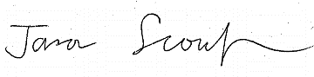
Jason Scoufis | Coordinator Traffic Investigations and Road Safety
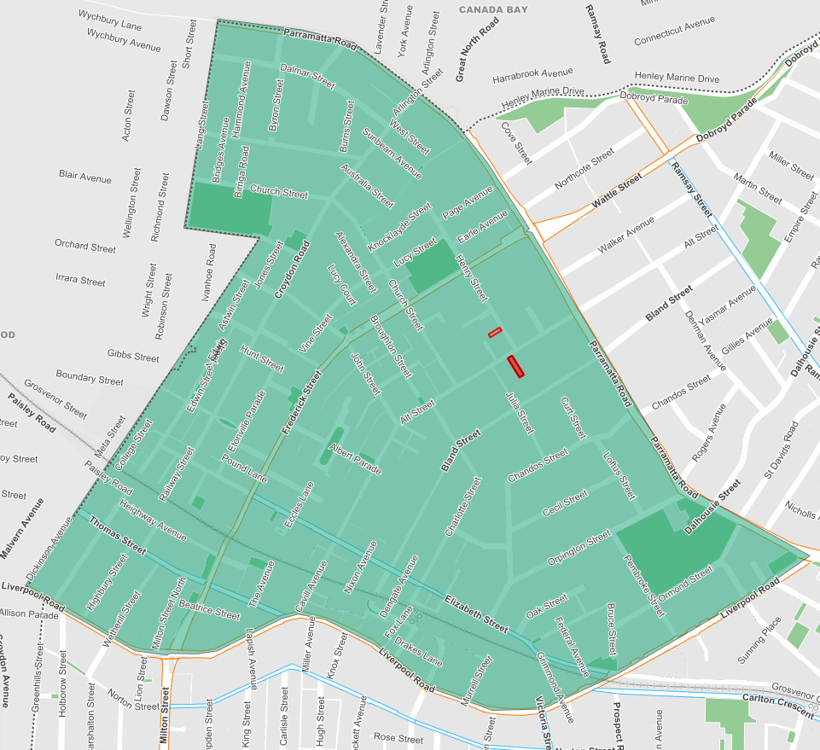
An outline of the consultation area for Ashfield North and Croydon.

