22 May 2024 AF:MW: 39208344

<First last name>
<Address 1>
<Address 2>
<Suburb NSW 1234>

Dear Owner/Resident,

Have your say
Proposed Resident Parking Scheme (RPS) expansion on Railway Parade, Pritchard Street, Breillat Street, Annandale Street, Weynton Street, Kentville Avenue and Buruwan Lane, Annandale

Background
Council has received requests from residents, for a review of the existing Resident Parking Scheme (RPS) in Railway Parade, Pritchard Street, Breillat Street, Annandale Street, Weynton Street, Kentville Avenue and Buruwan Lane, Annandale to better manage on-street parking in the area.

In November 2023, parking occupancy surveys were undertaken in the above streets and results indicated high parking occupancy levels, (above 85%) during different times of the day.

What is being proposed?
It is proposed to expand the Resident Parking Scheme (RPS) in theses streets, by installing ‘2P 8am-6pm, Monday to Friday, Permit Holders Excepted, Area A1', as shown in the attached plan.

Please note that as part of the proposal, statutory ‘No Stopping’ zones must be installed at all intersections as per NSW Road Rules, if the restriction is not already in place.

The proposal is shown in the plan enclosed in this letter.
Please note the following guidelines from Council’s Resident Parking Policy will apply:
- A minimum of 50% support from properties in the subject section is required for consideration to implement RPS. Each property will be entitled to a single preference only. Please note that multiple submissions will be counted as one.
- Eligibility for resident parking permit is as follows:

No. of off-street parking spaces on the property | No. of resident parking permit eligible
0 | maximum 2
1 | 1
2 or more | 0

- Proof of vehicle registered at the property is required for Resident Parking Permit application.
- One visitor parking permit will be offered per eligible property.
- Dual occupancies, multi dwelling housing and residential flat buildings, subdivisions into two or more lots and strata subdivision of residential flat buildings approved after January 2001 are not allowed to participate in a RPS, as off-street parking should be provided in accordance with Council’s parking Development Control Plan (DCP).
- Parking permits are not available for boats on trailers, box trailers, caravans, buses, and trucks (i.e., vehicles greater than 3 tonnes GVM).
- Residents who have signed petitions or made earlier request will still be required to complete Council’s survey.

Have your say
Let us know your thoughts on this proposal:
- Online via your yoursay.innerwest.nsw.gov.au/localtraffic and click on Rozelle Bay tile or scan the QR Code below to head directly to the project page
- By post to Inner West Council, PO Box 14, Petersham NSW 2049 c/o Amir Falamarzi
- By phone on 9392 5627
- Via email to amir.falamarzi@innerwest.nsw.gov.au

Feedback closes on Thursday 20 June 2024.

What happens next?
A report, including feedback from the community, will be considered by the Local Traffic Committee. Everyone who provides feedback will be notified when the report is considered by the Committee.

Enquiries
If you have any questions about this proposal, please contact Daniela Kiproff on 9392 5321 or email daniela.kiproff@innerwest.nsw.gov.au.

Yours sincerely,
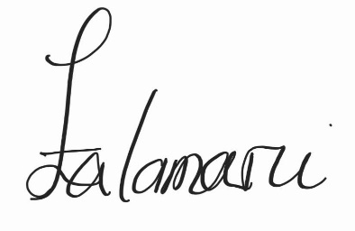

Amir Falamarzi | Traffic Engineer


