

18 September 2023

Addressee
Address1
Address2
Address3

Dear <name>

Have your say
Improving safety and managing traffic in Petersham North Precinct

Council has developed a draft Local Area Traffic Management (LATM) plan to address key concerns about traffic, pedestrian and cycling in the Petersham North Precinct. The area is bounded by West Street, Parramatta Road, Crystal Street and Terminus Street.
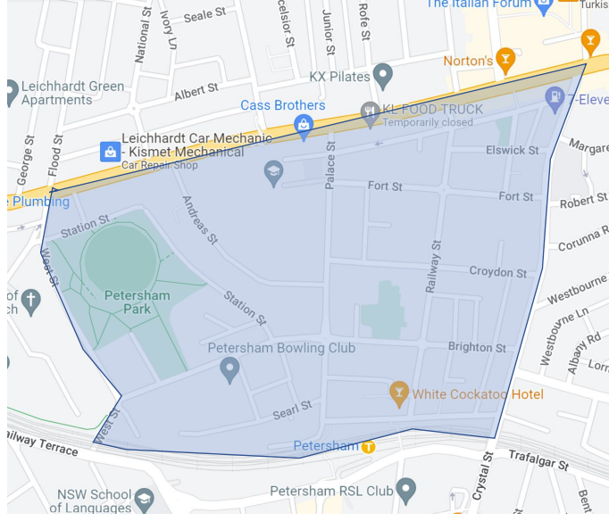
How was the draft plan prepared?
The plan has been developed using information from:
- initial community consultation in May-June 2022
- ongoing correspondence from the community about issues in the study area
- a review of traffic volumes, vehicle speeds and crash statistics in the area

What’s in the draft plan?
The plan includes recommended treatments and changes at locations shown in the attached map. The draft plan proposes treatments including raised pedestrian crossings, kerb blisters, speed humps, a 10 km/h shared zone and a roundabout.

Read the draft plan
There are two ways you can view the draft Petersham North LATM plan:
- Download a copy from yoursay.innerwest.nsw.gov.au or scan the QR code to go directly to the page
- Visit Petersham Service Centre, 2-14 Fisher Street, Petersham to view a hard copy

Have your say
Let us know your views on the draft plan:
- Online at: yoursay.innerwest.nsw.gov.au or scan the QR code
- By mail: addressed to Inner West Council, PO Box 14, Petersham, 2049. Please mark your feedback with reference – Petersham North LATM Study
- By email to shirley.rodriquez@innerwest.nsw.gov.au
- By phone contact Shirley Rodriquez on 93352274
Final day for comments is Sunday 29 October 2023

Next steps
Your feedback will be reviewed by the project team and where relevant incorporated into the plan. The plan will be considered by the Local Traffic Committee before the elected Council decides to adopt the plan. Everyone who provides feedback will be notified when the plan is being considered by Local Traffic Committee.

Enquiries
Should you have any queries or require a hardcopy of the feedback form mailed to you contact Shirley Rodriquez on 93352274 or shirley.rodriquez@innerwest.nsw.gov.au.

Yours sincerely,
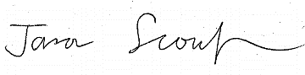
Jason Scoufis | Coordinator Traffic Studies & Road Safety

