

EVENT MANAGEMENT PLAN

Calvert St Carpark and Illawarra Ln
Designated Event Site 2025-2029

Event Details

  - Event Details
Name and date of the event to be supplied to Inner West Council on application for support under the global Activity Application Form (s68).

  - Event Manager:
Event Organiser details to be supplied to Inner West Council upon application for support under the global Activity Application Form (s68).

  - Event Description
A part of Transport for NSW’s Permit/Plug/Play Pilot Program, Inner West Council is creating three dedicated event sites across the LGA for use by the Community as part of a simplified Activity Application Form (s68) approval.

Calvert St Carpark and Illawarra Lane will be designated as a pre-approved event site for the following types of events
Event Types:
Commercial or Council-run event for:
- Market stallholders, or
- Music event
These events may allow liquor sales, subject to additional conditions placed on the event operator by Council, and appropriate licenses and approval from Office of Liquor and Gaming and/or NSW Police as appropriate.

Event Frequency:
- Up to 6 times per year on a Sunday through a simplified booking process, S68 approval from 2025-2029 inclusive
Event Operations:

Bump In | From 3:30am
Event Times | 11am to 4pm or 12:00pm-6:00pm
Bump Out | 6:00pm-11:30pm
Approved Capacity | Up to 2000 patrons, depending on the site layout

Event Footprint
This event is restricted to Calvert St carpark and Illawarra Lane as part that is indicated on the Site Plan. The remaining part of the street must not be occupied and be open to the public for access at all other times of the day and night when normally accessible.
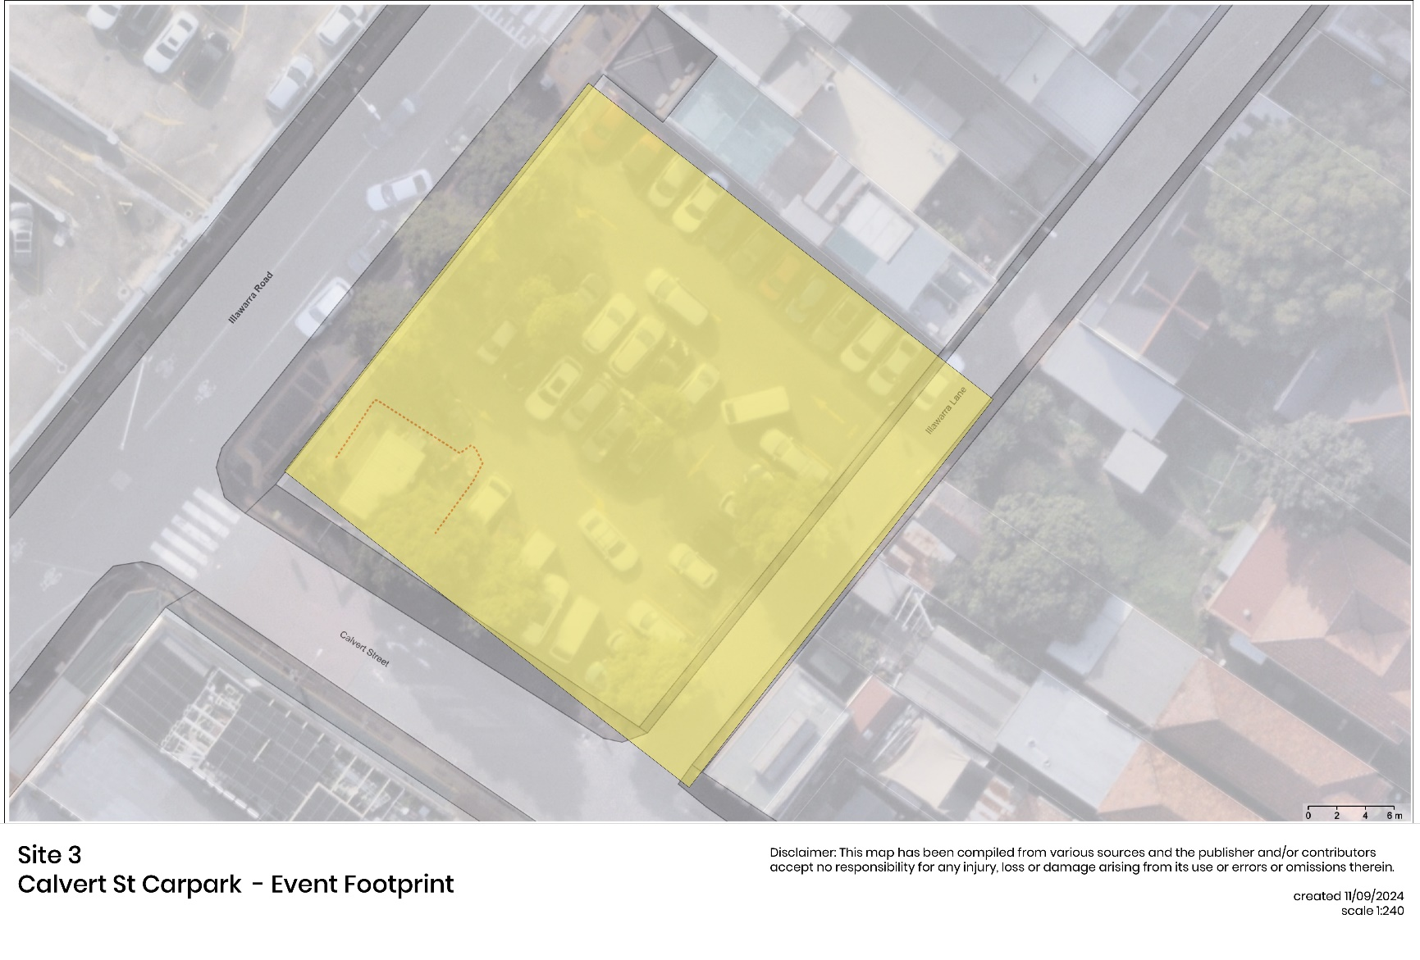
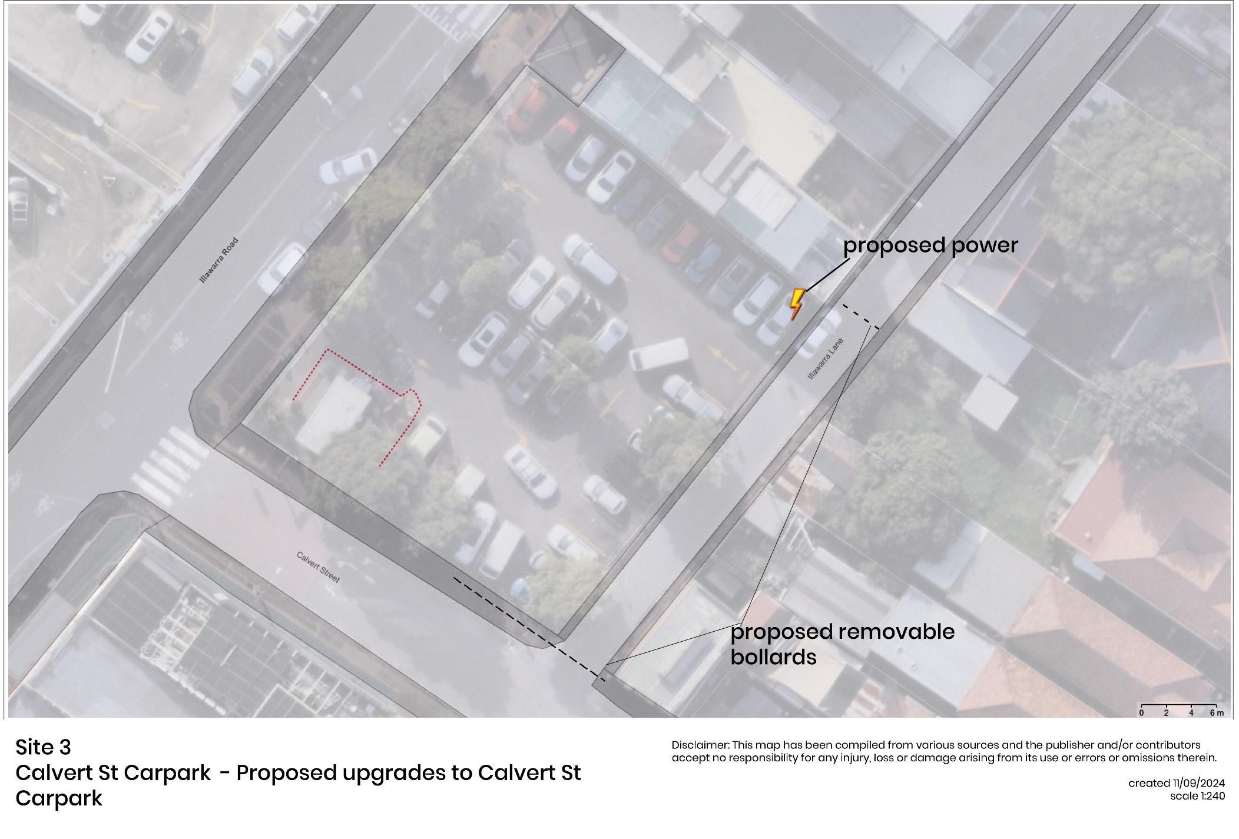
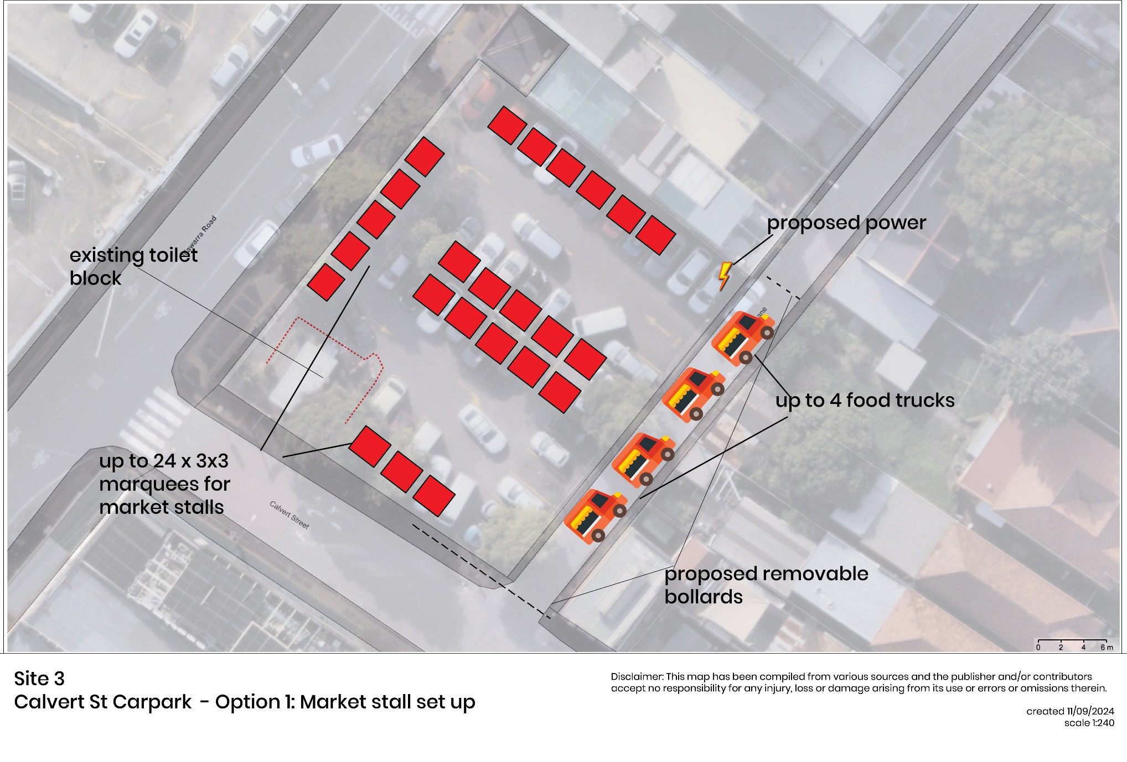
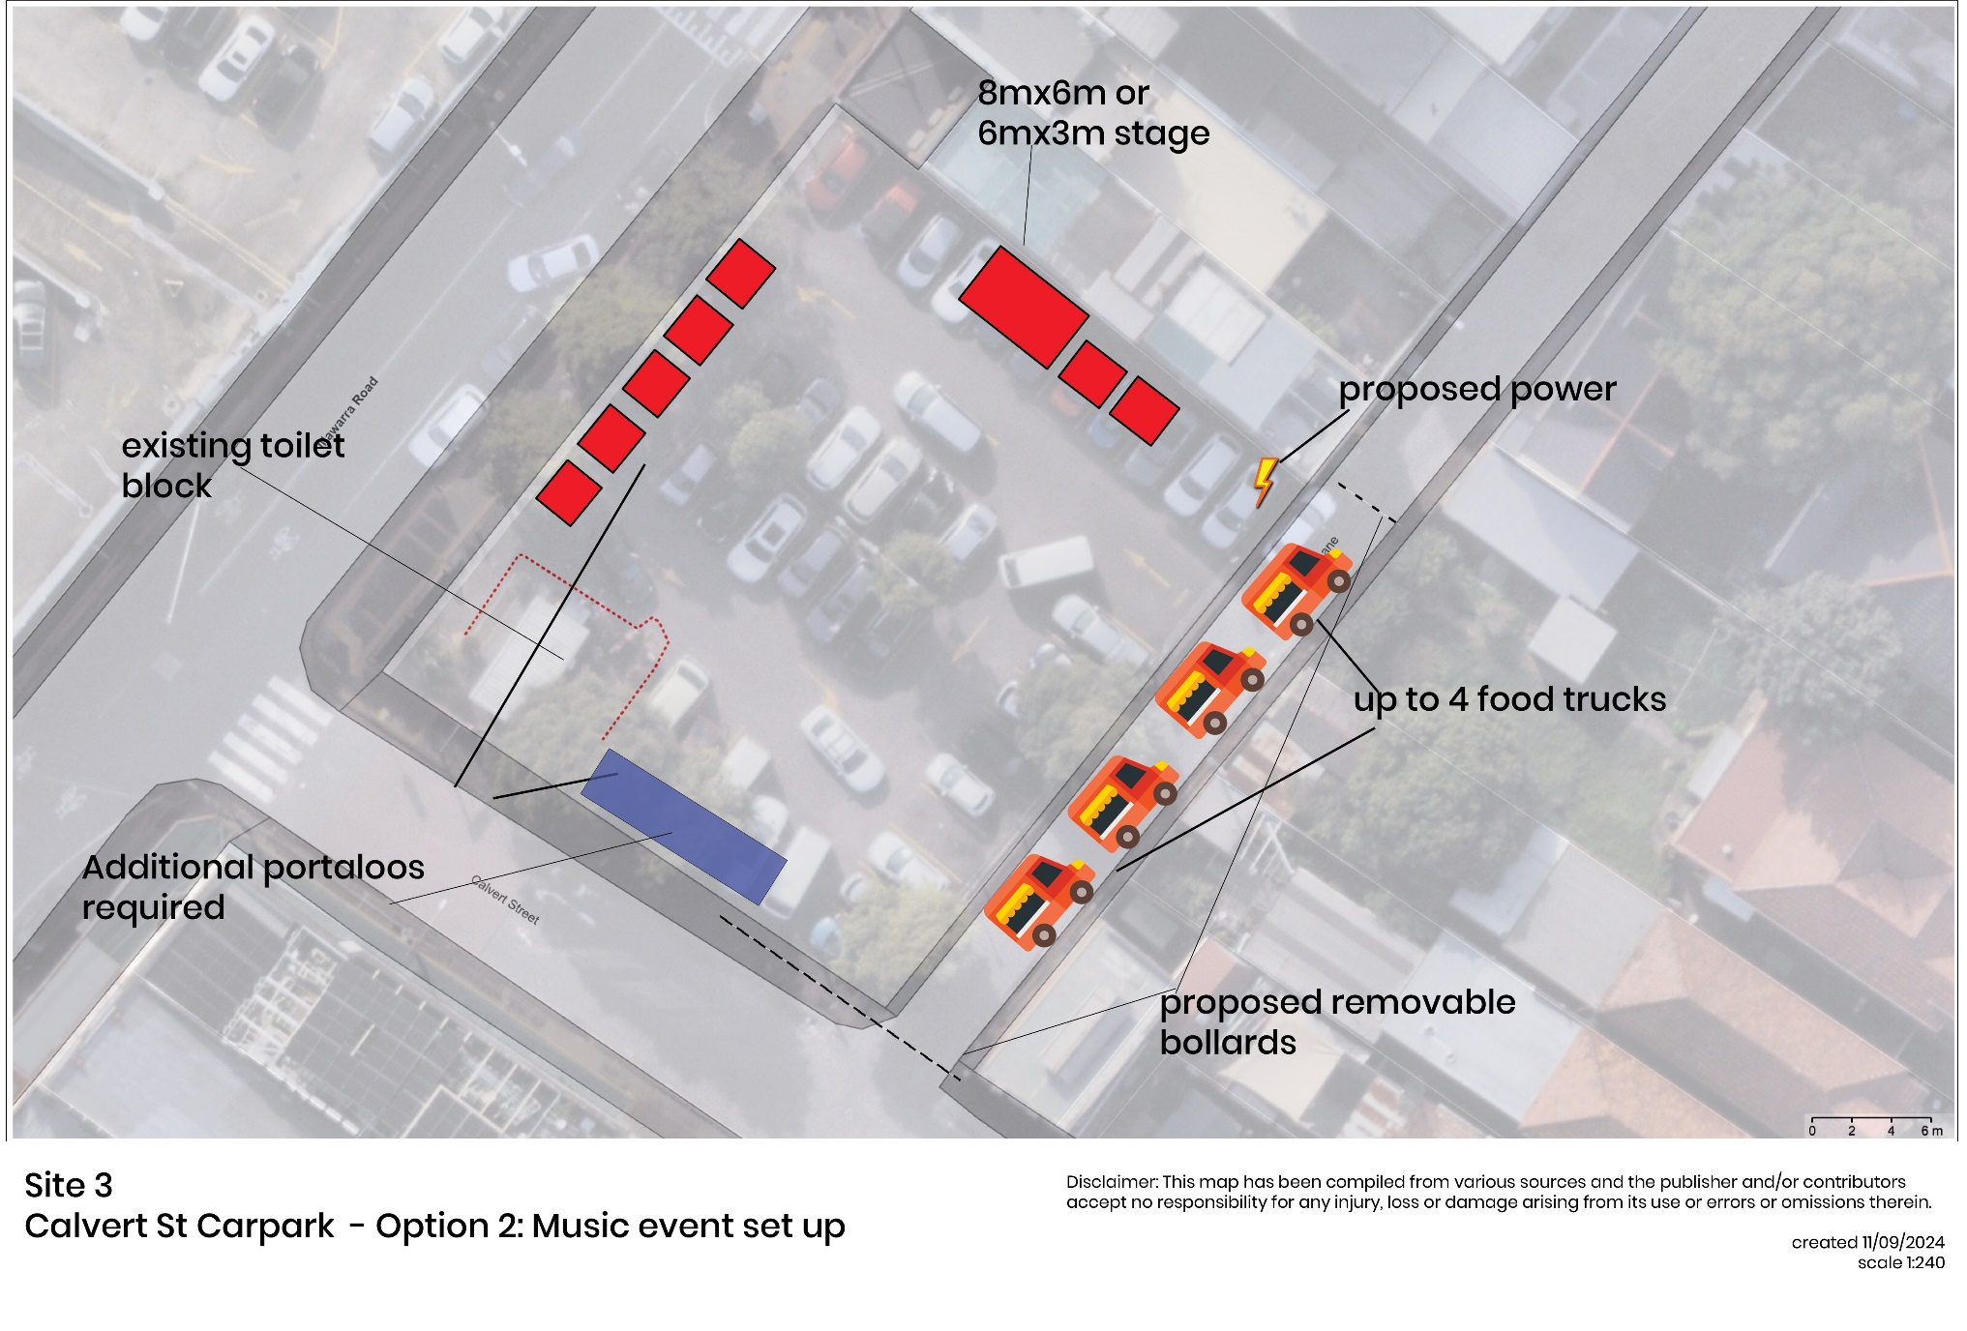
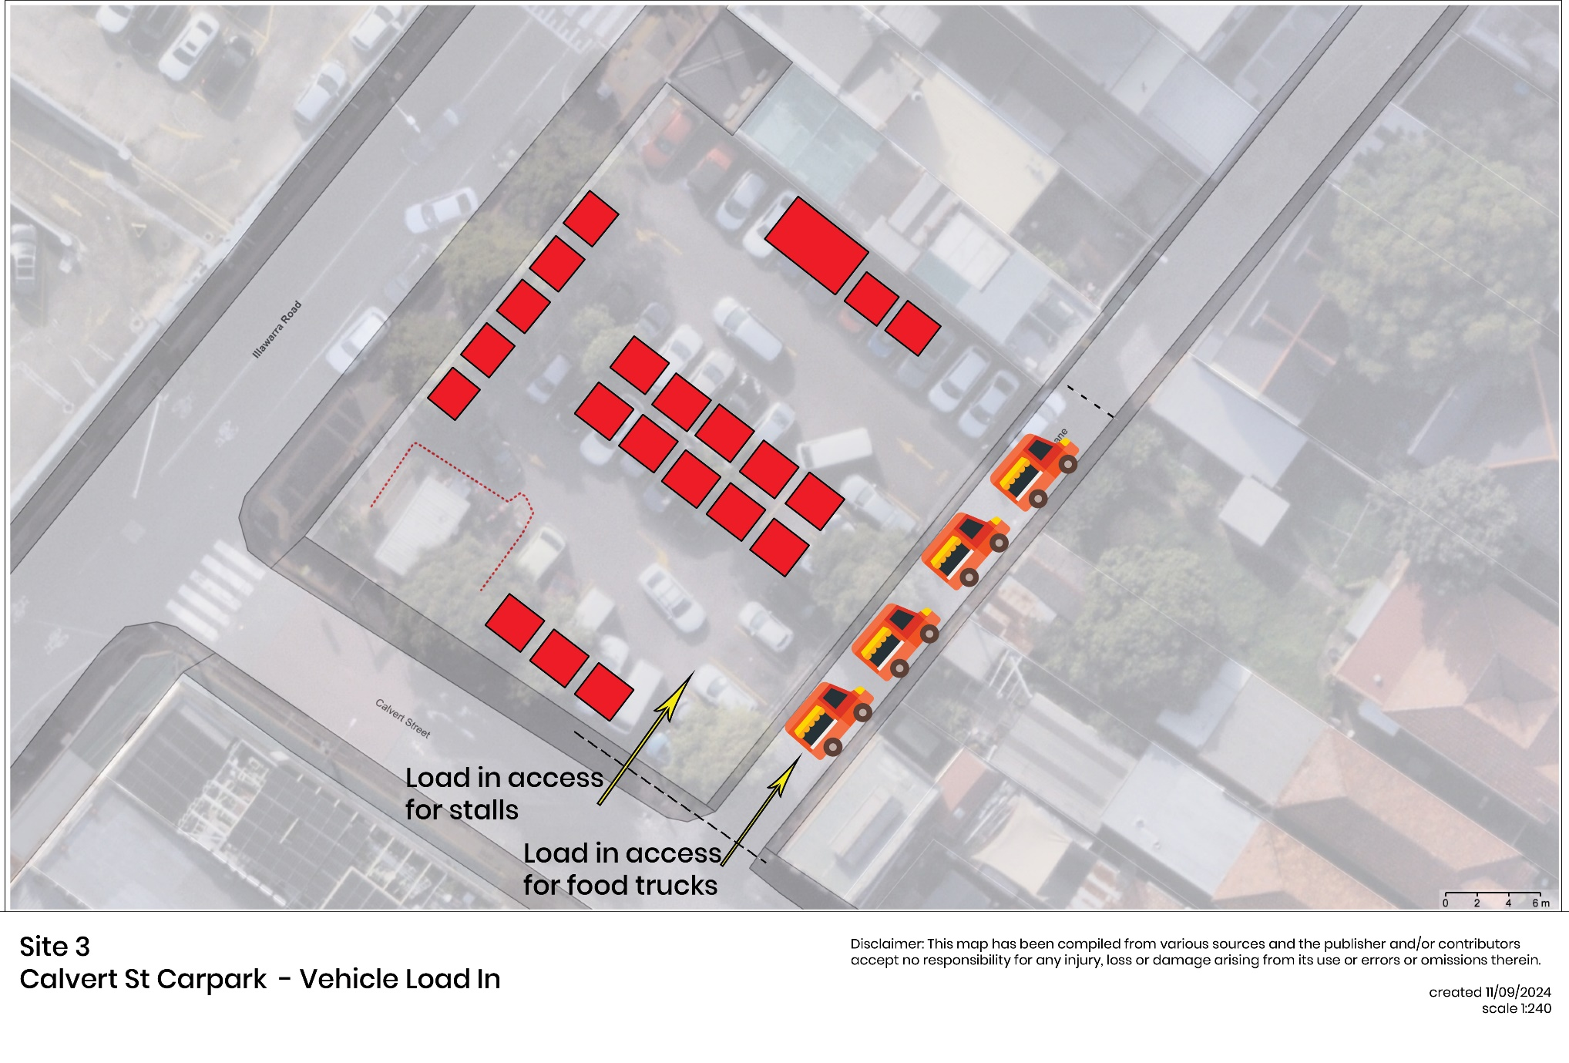
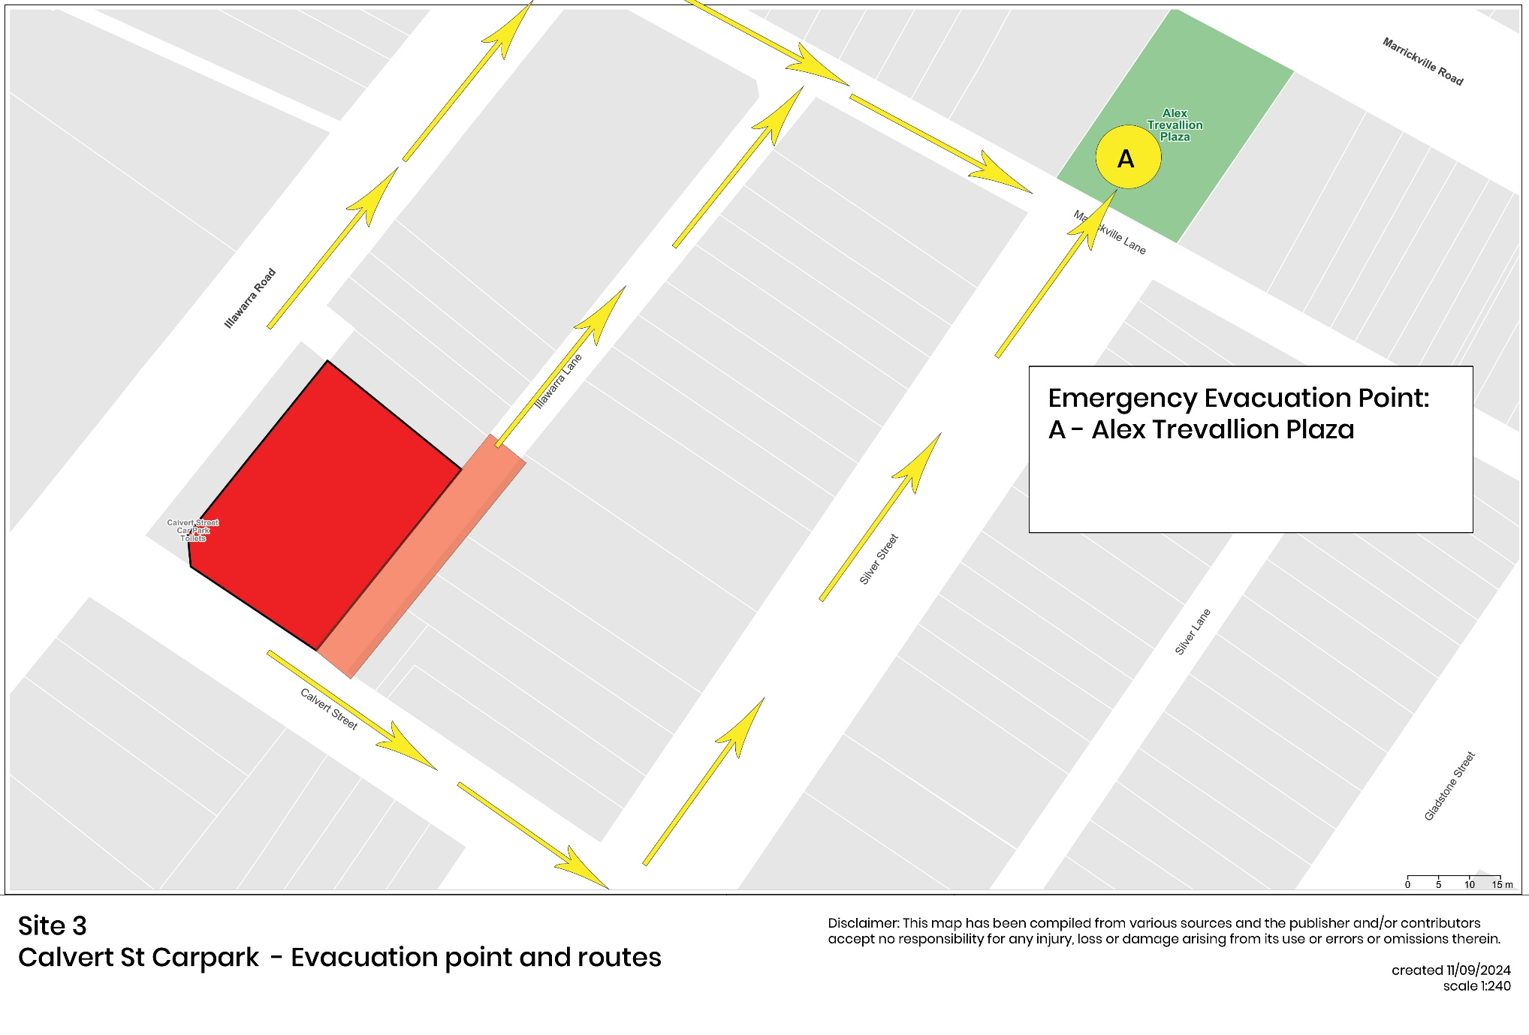
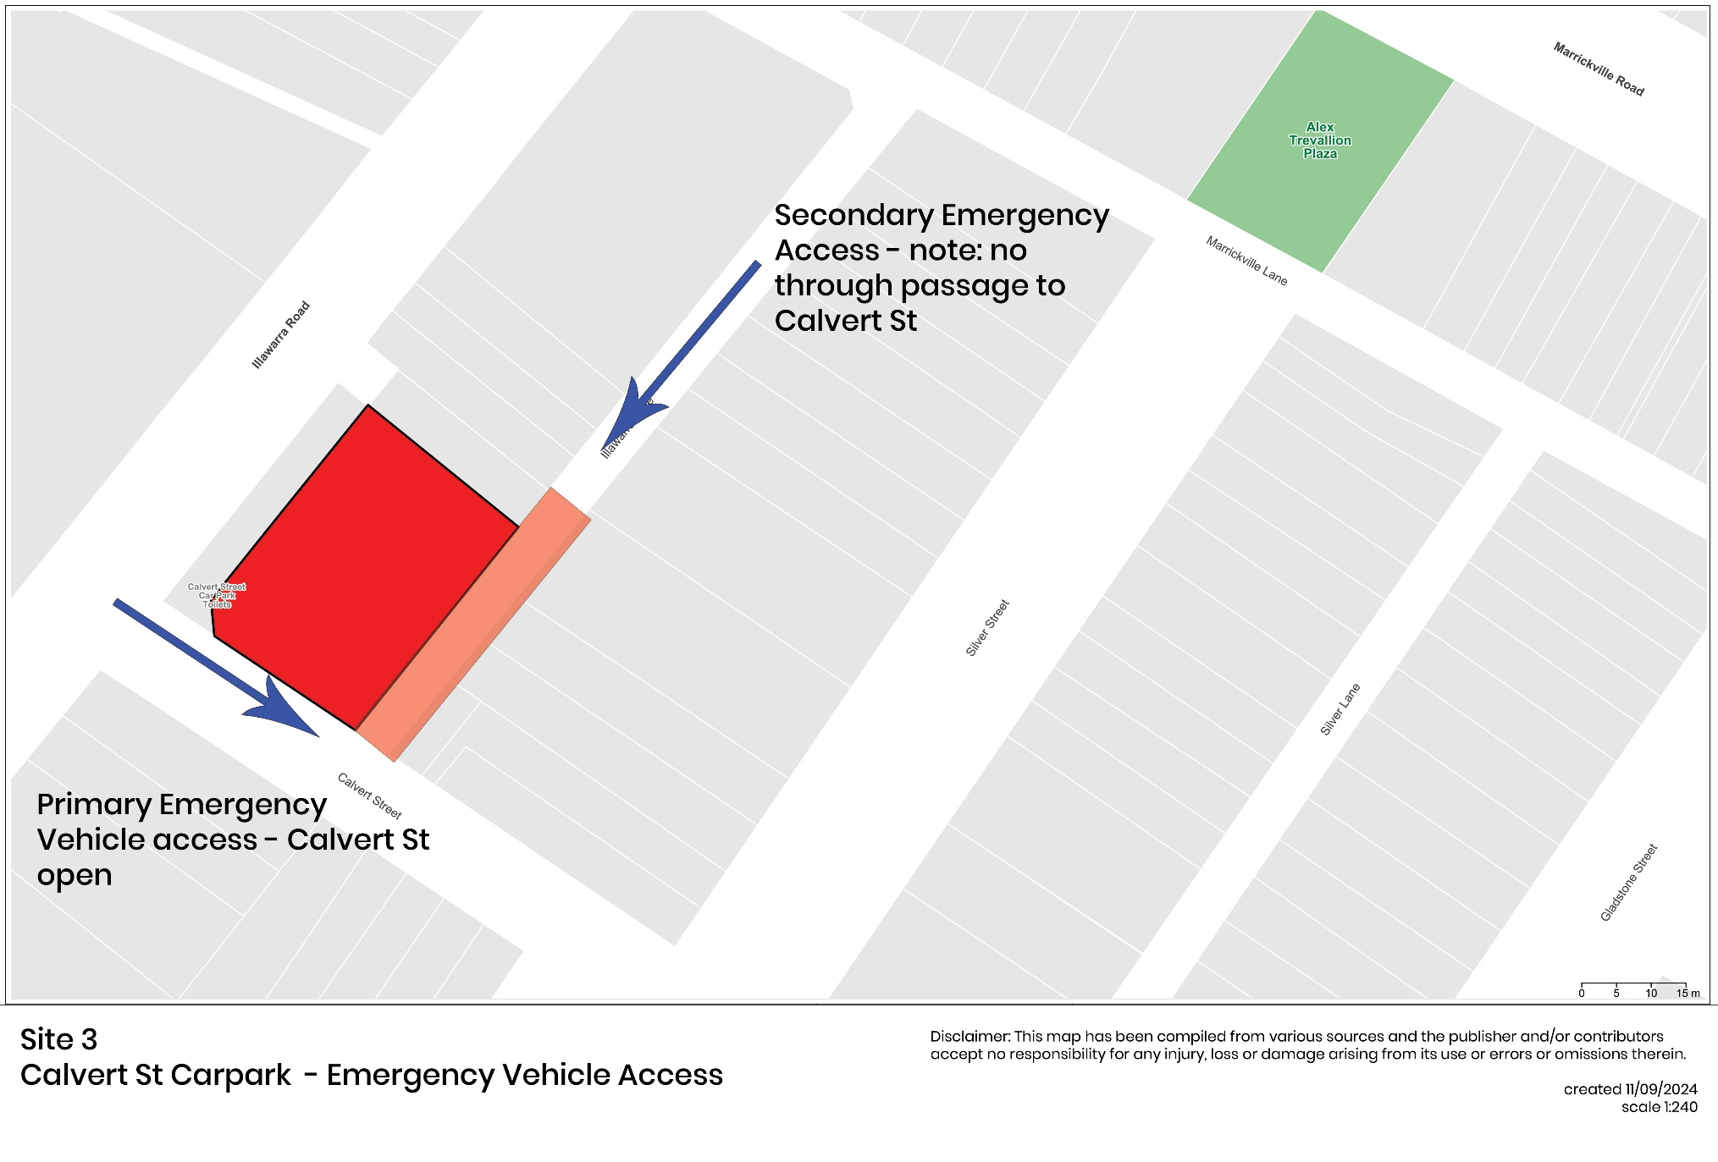
  - Infrastructure Plan

Temporary staging: Maximum size of 8m x 6m stage cover with a 60cm stage riser, plus 3x3 front of house and back of house tent as required
Stalls: Up to 24 3x3m Marquees
Food Trucks: Up to 4 food trucks
Portaloos: For music events with large crowds expected, additional portaloos will be required. Suggested number of toilets should follow NSW Government advice in conjunction with the event organiser’s risk assessment. Guidelines can be viewed here: https://www.nsw.gov.au/departments-and-agencies/premiers-department/community-engagement/event-starter-guide/health
All structures have wind ratings. A wind management plan should be in place outlining at which wind speeds certain items should be secured, and when to evacuate the area or site.
For safety reasons the event organiser should engage the services of an expert with relevant experience to build any structures required at the event.
Trees are not to be used to support power leads, water supply or any other items.
No stakes, spikes or pegs are permitted to be driven into the grounds to support the stalls and other structures on the entire site with weighted supports being used where required.
The installation and dismantling of temporary structures and stalls and use of equipment must be carried out in accordance with the provisions of the Building Code of Australia, relevant Australian Standards, manufactures specifications and the requirements of WorkSafe

Notification Plan

Residents and businesses in the immediate surrounding streets of the festival precinct will be notified via letter of the road closure 2 weeks prior to the event.
The below map identifies the area which will be notified - please see Appendix A for suggested wording for resident notification letter.

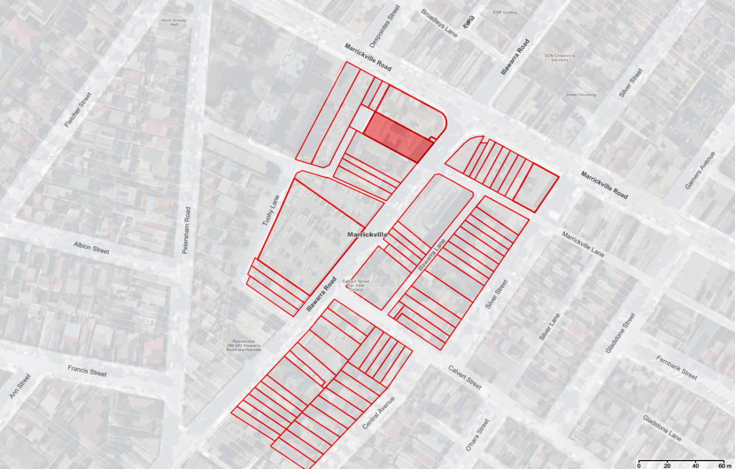

NSW Police Local Area Commander, Fire & Rescue NSW, and the Ambulance Service must also be notified in writing prior to the event.
Advance notifications signs advising of the proposed road closure and traffic diversions to be strategically installed and maintained by the applicant at least two (2) weeks prior to the event.

Risk Management
An event risk assessment to be provided to Inner West Council a minimum of 4 weeks prior to the event date.

Traffic, Parking & Transport Arrangements Plan

A global TMP will be available as part of the event application pack. Event organisers must ensure that they are compliant with the global TMP for Calvert St Carpark and Illawarra Lane
The Permit/Plug/Play pilot program will enable a streamlined approval and application process, to be developed by Council through the course of this project. Event organiser will need to apply to Council to enact the Global TMP through a revised application process. This will also include providing details of the traffic management company the event organiser has engaged to enact the plan. If there are any deviations from the approved TMP, the event organiser is required to produce a new traffic management plan for the site and standard application processes, fees and timelines will apply.
The event organiser is required to obtain consent from TfNSW for the use of the road space through a Road Occupancy Licence application under section 138 and section 115 of the Roads Act 1993. The road space is reserved by TfNSW for the event and may impose conditions on the use of the road space to ensure the safety of participants and the public. A Road Occupancy Licence will be required to be submitted a minimum of 10 business days prior to your event.
A minimum of two weeks before the event, the event organiser shall sign a written undertaking that they shall be responsible for the full cost of repairs to footpath, kerb and gutter, or other Council property damaged as a result of the event. Council may utilise part or all of any Damage Deposit or Bond or recover in any court of competent jurisdiction, any costs to Council for such repairs.

Noise and Noise Control Plan
The event running times and distance from residential properties between pose a very low threat of noise disturbance to the surrounding neighbours.
Event organiser must engage a professional audio company to outdoor noise restrictions. The cumulative broadband LAeq, 10-minute noise level emitted from all entertainment, patrons, and amplified noise associated with the use must:
a. Not exceed 65 dB(A) at the boundary of any residential premises between the hours of 12pm-6pm
b. Not be audible inside any habitable room of any residential premises at any other time. As a guideline to resolving low frequency noise issues, the LCEq, 10 minute should not exceed 75 dB(C) during these times.
During event times, noise must be monitored hourly by event staff, and adjustments made as necessary.
Hearing Protection: Encourage the use of earplugs and provide them at strategic points around the venue.

Waste Management Plan
Event organiser to ensure that appropriate additional waste services are engaged for events at this site. The event organisers must ensure that an adequate number of waste and recycling bins are provided for the event and distributed in suitable and accessible locations throughout the event area. All waste and recycled materials being collected, sorted, and stored in accordance with details submitted to Council with the application for consent.
Any waste management and/or clean up services required to be provided by Inner West Council resulting from the event must be undertaken at the expense of the person acting on this consent and at no cost to Council.
The areas to be used for the activities must be maintained in a clean and tidy condition to the satisfaction of Council’s Group Manager Roads and Stormwater, or else the event manager will be required to reimburse Council for any extraordinary cleansing costs

Temporary WCs Management Plan
There is an existing toilet block on Calvert St Carpark. For music event with large crowds expected, additional portaloos will be required. Event organised to engage appropriate number of portaloos for the size and scale of the event, to be placed in line with the approved site map. Minimum of 1x accessible toilet to be placed located close to any accessible viewing area, for ease of access.
Suggested number of toilets to follow NSW Government advice https://www.nsw.gov.au/departments-and-agencies/premiers-department/community-engagement/event-starter-guide/health

Disability Access Management Plan
When planning an event, the event organiser is legally required to provide access for people with disability. The event site is a public area, utilising public road space and footpaths, providing step-free access to the event site.
Event Managers are encouraged to utilise the Toolkit for Accessible and Inclusive events, available at the NSW Government website: https://www.nsw.gov.au/sites/default/files/2023-07/Toolkit-for-Accessible-and-Inclusive-Events.pdf

Crime Prevention & Security Management Plan

10.1 Security
Event organiser to ensure appropriate security measures are to be taken for this event. Your risk management plan may identify high-security risks that are likely to occur at the event. If you do contract a security company, it is advisable to liaise with them during the event planning stage.
The event organisers are responsible to ensure that security staff give appropriate directions to and take reasonable steps to control noisy or offensive behaviour of persons entering or leaving the event.
For most large events where alcohol is served, the licensing arrangements will require a minimum number of security officers be employed, who have been trained in the responsible service of alcohol.
The event manager must comply with the following terms of approval as per NSW Police recommendation:
a) No more than 4 alcoholic drinks (whether or not of the same kind) may be sold or supplied to the same person at any one time.
b) Free water is to be available at all times at each liquor selling point.
The licensee must maintain an incident register at all times during the event and operating for the sale or supply of liquor.
a) The licensee must record in the register the details of any of the following incidents and any action taken in response to any such incident:
i. Any incident involving violence or anti-social behaviour occurring on the premises;
ii. Any incident of which the licensee is aware that involves violence or anti-social behaviour occurring in the immediate vicinity of the premises and that involves a person who has recently left, or been refused admission to the premises;
iii. Any incident that results in a person being turned out of the licensed premises under section 77 of the Liquor Act 2007;
iv. Any incident that results in a patron of the premises requiring medical assistance; and
v. Notwithstanding the above, any incident of a person being refused service.
b) The licensee must if request to do so by a police officer or inspector:
i. Make any such incident register immediately available for inspection by a police officer or inspector; and
ii. Allow a police officer or inspector to take copies of the register or to remove the register from the premises.
  - Access Control
Traffic, transport, and pedestrian arrangements are developed as part of the associated global TMP for this site. Removable bollards are proposed to be installed at this site to assist with vehicle mitigation and access to the event site. The event organiser must ensure that residents are notified and appropriate arrangements are made to ensure that the event site is free from cars.
For an approved licensed event, security to be placed at entry points to carpark in accordance with the event organiser’s developed security plan.
  - Territorial Reinforcement
Inner West Police Area Command should be briefed a minimum of 60 days prior to the event. NSW Police may require Úser Pays police to be engaged by the event organiser at their own cost.
If police are present at the event, whether on general duty or on a user pays basis, event organisers are not entitled to direct the activity of police or to have inappropriate influence on operational commands. However, the event organiser should liaise with the NSW Police Force in the lead-up to the event and agree how issues or concerns can be raised on event day.
10.4 Space Management.
Event staff and security (if engaged) should assist with patron safety, evacuation plan, and safe bump in and bump out of the event.
The event is to be a smoke-free event to comply with Council’s Smoke-Free Outdoor Environments Policy. The organisers of the event are required to ensure that the event is promoted as smoke-free and to advise all stallholders that smoking is prohibited. A condition to reflect the above being incorporated into all stallholders’ agreements.

. Supporting Documents - Emergency Management Plan

The event organiser is responsible for developing an emergency management plan appropriate to the event. A risk assessment and emergency management plan specific to your event will need to be submitted when booking this site.

Appendix A Template Resident Notification Letter

EVENT NOTIFICATION
SPECIAL EVENT ROAD CLOSURE – Calvert St Carpark and Illawarra Lane
[DATE] [Event Name]

Dear Resident,

[Event Organiser] is presenting [Event Name] on [Event Date and year] from 12pm-6pm [update if required].

[insert description of event]

The event includes a full road closure of Calvert St Carpark and Illawarra Lane between 3:30am and 11:30pm
It is important to take note of these road closures. If your vehicle is parked in an external or internal car park within the event site, you will not be able to move your vehicle for the duration of the road closure. Vehicles parked on the above roads during this time may be towed.

This event is supported through the Permit/Plug/Play Pilot Program initiated by the NSW Government, through a series of designated event sites within the Inner West Council Local Government Area.

For further information, please visit [event website] or please call [event organiser’s phone number] or email [email address].

Sincerely,

[Event Organiser]

