Engagement outcomes report

Draft Car Share Policy



Contents
Summary 3
Background 3
Engagement Methods and Promotion 4
Promotion methods 4
Engagement outcomes 6
Who did we hear from? 6
What did they say? 9
Officer comments in response to public exhibition 13

Summary

The draft Car Share Policy aims to harmonise and consolidate the car share policies and practices of the former Ashfield, Marrickville and Leichhardt councils to provide a consistent framework for the application, installation and management of designated car share spaces in public streets and car parks owned and/or managed by council.

The draft Car Share Policy was placed on public exhibition between 17 March and 28 April 2021 to obtain feedback from the community and car share operators. During the 41-day exhibition period the project page on Your Say Inner West received 701 visits with 194 people downloading the draft policy and 142 people responding to the online survey.

Most comments received were supportive of car sharing services, making a number of suggestions about how the policy could be improved. The draft policy has been amended in response to feedback as outlined below.

Background

Car sharing services are well established in the Inner West Local Government Area (LGA) with more than 14,000 existing members and it was supported by the policies of the former Ashfield, Marrickville and Leichhardt councils.

Alongside the Public Domain Parking Policy, the draft Car Share Policy is an operational policy for managing public space for car parking. It outlines steps car share operators and council officers would follow for application, assessment and installation of new car share parking spaces located on public streets and in car parks that are owned or managed by Inner West Council. It outlines the obligations of car share providers for using public space as well as criteria for imposing costs associated with using public space for the parking of shared cars.

Engagement Methods and Promotion

Promotion methods

The public exhibition period was promoted using a number of methods including the following:

- A project page for the draft policy was displayed on Your Say Inner West with notification given to the subscribers to the Your Say Inner West newsletter.
- Notification of the exhibition period was issued via council’s social media.
- Convenors of the following Local Democracy Groups were notified of the exhibition period and asked to request members take part in the engagement:
- Transport Advisory Committee
- Bicycle Working Group
- Access Advisory Committee
- Senior’s Working Group

The graph below shows the different ways survey respondents were informed about the exhibition period including council social media posts, notification by other parties, Your Say Inner West and word-of-mouth.

How did you hear about this project? (select all that apply)

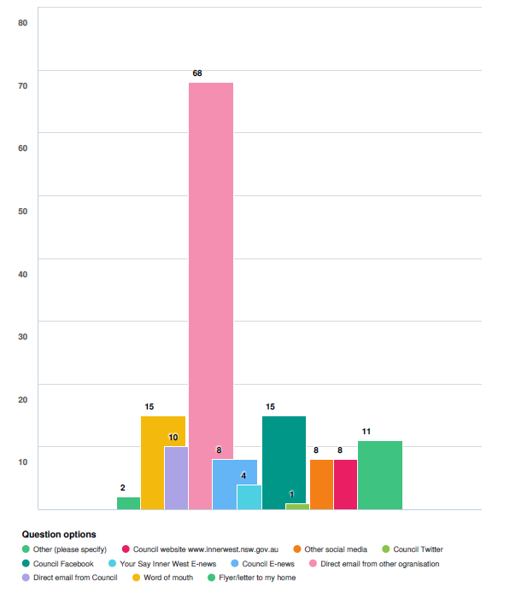

Responses

Options | Number of responses
Other | 2
Council website www.innerwest.nsw.gov.au | 8
Other social media | 8
Council twitter | 1
Council Facebook | 15
Your Say Inner West E-news | 4
Council E-news | 8
Direct email from other organisation | 68
Direct email from Council | 10
Word of mouth | 15
Flyer to my home | 2

Engagement methods

The draft Policy was placed on public exhibition between 17 March and 28 April 2021 with the exhibition period was extended beyond the usual 28-day period due to school holidays.
Following direct engagement with car share operators and the community throughout development of the draft policy during 2020, the following engagement methods were used during the public exhibition period:
- Online feedback was sought from the community via the Your Say Inner West project page on specific elements on the draft policy.
- Online submissions could be made by car share operators via the Your Say Inner West project page
- Email feedback was provided directly to staff.

Engagement outcomes
The Your Say Inner West project page included an online survey with questions about specific elements of the draft policy and 142 responses were received. Nine submissions were received on the draft policy including three from car share operators.

Who did we hear from?
Online via yoursay.innerwest.nsw.gov.au
As reflected by the graphs below, from 142 responses to the survey 136 were received from residents of the Inner West LGA with slightly more than 80 percent of survey respondents being car share members.

Nine submissions were received on the draft policy including three from car share operators, one from a climate change community group and one from a member of the Senior’s Working Group.

Which best describes your relationship to the Inner West? (select all that apply)
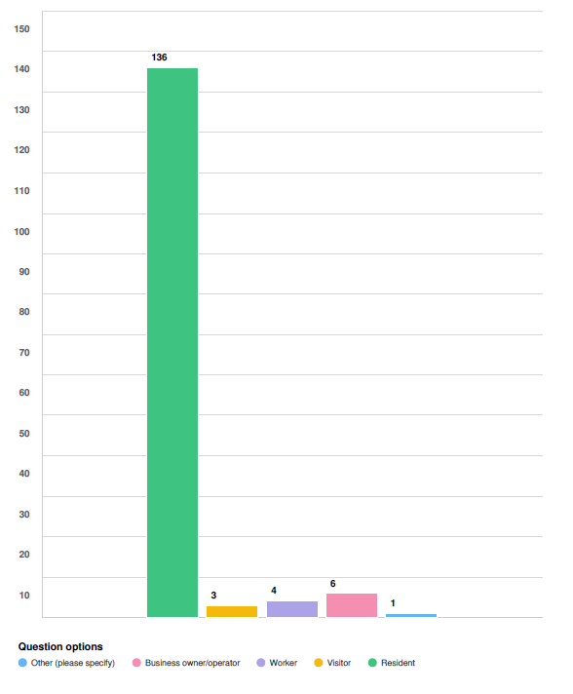

Responses
Options | Number of responses
Resident | 136
Visitor | 3
Worker | 4
Business owner/operator | 8
Other (please specify) | 1

Are you a member of a car share scheme?

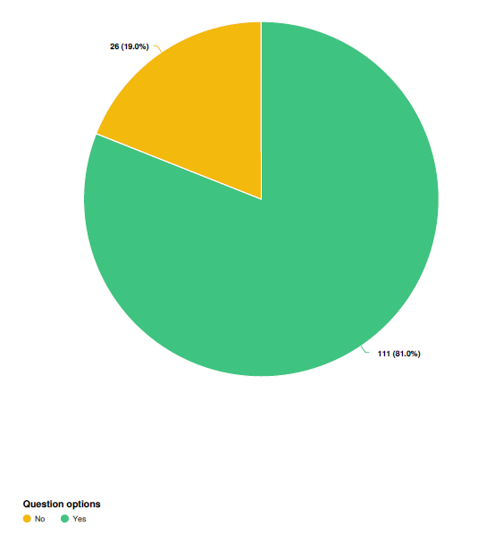
Responses
Options | Number of responses
Yes | 111
No | 26

What did they say?

Question one asked respondents whether they agreed with the aims of the draft Car Share Policy including easy availability of car share vehicles throughout the Inner West and the provision of vehicles by different car share operators. The graphs below show the majority of respondents either agree or somewhat agree with the aims for easy availability of car share vehicles throughout the LGA and the provision of vehicles by different car share operators.

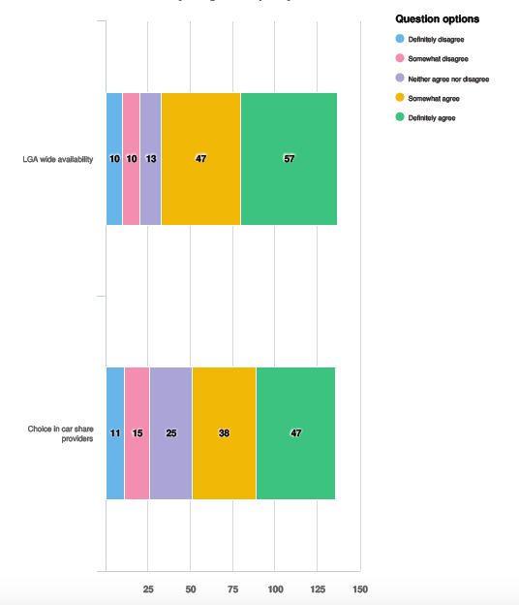

Responses
LGA wide availability
Options | Number of responses
Definitely disagree | 10
Somewhat disagree | 10
Neither agree or disagree | 13
Somewhat agree | 47
Definitely agree | 57

Responses
Choice in car share providers
Options | Number of responses
Definitely disagree | 11
Somewhat disagree | 15
Neither agree or disagree | 25
Somewhat agree | 38
Definitely agree | 47

Survey question three asked respondents about Clause 6.2 which outlines a hierarchy for where new car share vehicles would be located. The hierarchy prioritises car share parking close to public transport services, adjacent to public land/facilities such as parks, leisure centres and libraries, within high/medium density residential areas, in or near retail / commercial streets and adjacent to the side boundary of single dwellings.

Respondents were asked whether we got the hierarchy right and the chart below shows that about one third of people responded ‘yes’ and about one third of people responded ‘no’ to this question with the remainder either neutral or unsure. The hierarchy in the draft policy has been taken from the Public Domain Parking Policy which is now under review and this hierarchy can be reconsidered as part of the review.

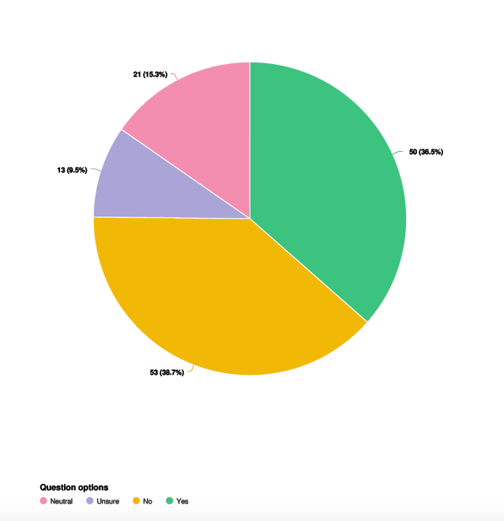

Responses
Options | Number of responses
Yes | 50
No | 53
Unsure | 13
Neutral | 21

Submissions received from car share operators

Three submissions were received from car share operators and the table below outlines comments received from the operators and staff’s response.

Issue from community engagement | Key Area | Action/Amendment
The requirement to provide a replacement car for long bookings fails to reflect the different ways members use car sharing services. | Clause 4.4 stated a replacement car was to be provided for long bookings. | This clause has been deleted. Instead the policy aims to support a network of vehicles to ensure members have access to other vehicles when longer bookings are made.
The maximum carbon dioxide emissions specifications should be applied to the whole fleet instead of individual vehicles. | Clause 5.1 specified maximum carbon dioxide emissions per vehicle. | As outlined above the policy has been revised to specify a maximum combined average for three different categories of vehicle.
The maximum limit of three applications in the system at any one time would inhibit new operators and restrict operators from keeping-up with demand. | Clause 6.7 specifies a maximum of three applications in the system at any one time. | Part 6.7 has been included due to limited staff resources for administering this policy. This can be re-considered in future if circumstances change. This clause does not preclude a council authorised car share company from operating floating car share vehicles.
The availability of cars is a major factor in people adopting car share and to support this a network of cars are needed so cars are available when members need them. This is particularly important for new operators wishing to operate in the Inner West LGA. | N/A | The policy aims to support a network of vehicles to ensure members have access when needed and new operators are encouraged to contact council to work in accordance with the policy to implement car share vehicles in designated parking spaces.
The policy should include provisions to enable new operators to establish a base fleet of designated parking spaces including allowing more applications than the maximum of three specified in Part 6.7. | N/A | The policy aims to support a network of vehicles to ensure members have access when needed. Part 6.7 has been amended to better support commencement in the LGA by new operators and new operators are encouraged to contact council to work in accordance with the policy.
A ‘roadmap’ be considered for new operators wishing to operate in the Inner West to provide confidence in the investment required to establish a network of cars. For example it could involve commencing operations in part of the LGA instead throughout the entire area. | N/A | The policy aims to support a network of vehicles to ensure members have access when needed. Part 6.7 has been amended to better support commencement in the LGA by new operators and new operators are encouraged to contact council to work in accordance with the policy, such as implementing a network of vehicles within a specific area.
The requirement to provide telephone and email contact details staffed 24-hours per day 7-days per week is unreasonable. Emergency staff are provided outside business hours, with operator staff provided during business hours. | Clause 5.4 requires operators to provide telephone and email contact details staffed 24-hours per day 7-days per week. | Emergency staff provided outside business hours satisfies the intention of part 5.4 which aims to ensure council staff can contact operators in cases of emergency.

Officer comments in response to public exhibition

The table below outlines issues which were raised four times or more and the staff response to these issues.

Issue from community engagement | Key Area | Action / amendment
Residential locations, especially medium/high density locations, should be highest on the hierarchy of locations because residents need the cars near their homes. | Clause 6.2 specifies a hierarchy for the types of locations where applications for new shared cars would be prioritised. | The hierarchy has been taken from the Public Domain Parking Policy which was adopted in June 2020 only for the former Ashfield and Marrickville Council areas.  The hierarchy nominates popular public locations to optimise access and provide integrated transport options. While this section outlines locations where new car share parking spaces would be prioritised, it does not preclude applications for parking in other types of locations.  The review of the Public Domain Parking Policy will allow this issue to be re-considered.
Members are concerned that operators will prohibit long bookings as a result of clause 4.4. | Clause 4.4 required operators to provide a replacement car with bookings of 4 days or more. | This clause has been deleted. Instead the policy aims to support a network of vehicles to ensure members have access to other vehicles when longer bookings are made.
A good distribution of vehicles throughout the LGA is most important. | Clause 6.2 specifies a hierarchy for types of locations where new shared cars would be prioritised. | The hierarchy has been taken from the Public Domain Parking Policy which was adopted in June 2020 only for the former Ashfield and Marrickville Council areas.  The hierarchy nominates popular public locations to optimise access and provide integrated transport options. While this section outlines locations where new car share parking spaces would be prioritised, it does not preclude applications for parking in other locations.  The review of the Public Domain Parking Policy will allow this issue to be re-considered.
Parking for shared cars reduces street parking for residents who use the street for car parking. | N/A | Currently more than 14,000 residents and businesses in the Inner West LGA are car share members. Car ownership by these households and businesses would increase the demand for street parking significantly. Cars shared by households and businesses serves to reduce the demand for on-street car parking.
The clause stating car share parking spaces located in front of single dwellings will be given low priority should be deleted. | Clause 6.3 states car share parking spaces located in front of single dwellings will be given low priority and avoided in most circumstances. | Clauses 6.3 does not preclude car share parking outside single dwellings however alternative nearby locations will be explored initially.
New car share parking should be based on demand. | N/A | Currently there is one car share operator functioning in the Inner West LGA and any requirement to base the provision of new car share parking on demand or rates of use would significantly advantage the established operator.

A small number of submissions referred to Clause 5.1 of the draft policy which specifies the maximum CO2 to be emitted by individual cars.

Feedback received said the limit on vehicle emissions should be more ambitious and should be applied as an average across the whole fleet instead of individual vehicles. The draft policy has been amended to reflect these comments. The policy has been revised to specify a limit on the combined average of carbon dioxide emissions for three vehicle categories as follows:

Hatchbacks / sedans | 150g/km
Sports Utility Vehicles (SUV) | 180g/km
Vans / people movers | 230g/km

In addition a further clause has been added to the policy encouraging car share operators to
to achieve the following combined average of carbon dioxide emissions for each vehicle category within five years of adoption of the policy with annual reporting required on each category:

Hatchbacks / sedans | 128g/km
Sports Utility Vehicles (SUV) | 162g/km
Vans/people movers | 219g/km

The emissions targets specified for the future are subject to ongoing monitoring and review. It is recognised that the technology associated with different vehicle types are advancing at different rates and Council is keen to work with car share operators to facilitate increased opportunities for electric vehicles to be used in the Inner West LGA, including the exploration of charging facilities.

