<7th June 2024>
CE/MW/37751398 37751398 37751398

<First last name>
<Address 1>
<Address 2>
<Suburb NSW 1234>

Dear resident

Have Your Say
Investigating Resident Parking Scheme in the vicinity of Dawn Fraser Baths, Balmain

Background
Several residents have expressed concerns to council about the long-term non-resident parking along the vicinity of the Dawn Fraser Baths.

In response Council has conducted parking occupancy surveys in the vicinity of Dawn Fraser Baths. The results showed high parking occupancy levels, (above 85%) within several streets during the day.

What is being proposed?
It is proposed to introduce a Resident Parking Scheme (RPS) within the sections shown in the enclosed plan and outlined below:
- Installation of ‘2P 8am-10pm Permit Holders Excepted Area B1’ in the below sections (also shown within enclosed plan):
  - The Southern side of Fitzroy Avenue
  - Glassop Street between Punch and White Street, Balmain
  - The Western side of White Street between Tilba Ave and Glassop Street, Balmain
- As part of the proposal, 10m ‘No Stopping’ zones must also be installed at all intersections (as per NSW Road Rules) if the restriction is not already existing.

How does Council determine whether RPS will be implemented?
- A minimum of 50% support from properties in the subject section are required for consideration to implement an RPS. Each property will be entitled to a single preference only – please note that multiple submissions will be counted as one.

If the proposal succeeds, who can apply for a resident parking permit?
The scheme has a maximum of 2 resident parking permits and 1 visitor parking permit for each eligible property (properties with frontage to the proposed RPS area). The eligibility criteria and permit allocation are shown in the table below:

Number of Off-Street Parking Spaces at Property | Number of Eligible Permit Type
Number of Off-Street Parking Spaces at Property | Resident Parking Permit | Visitor Parking Permit
0 | 2 | 1
1 | 1 | 1
2 or more | 0 | 1

- Dual occupancies, multi dwelling housing and residential flat buildings, subdivisions into two or more lots and the strata subdivision of residential flat buildings, approved after January 2001, are NOT eligible to participate in Council’s Parking Permit Scheme.
- Multi-dwelling units with visitor parking within the premises will not be issued visitor parking permits.
- Parking permits are not available for boats (on trailers), box trailers, caravans, buses and trucks (i.e. vehicles greater than 3 tonnes GVM).
- Proof of vehicle registered at the property is required for resident parking permit application

Have your say
Let us know your views on this proposal:
- Online via your yoursay.innerwest.nsw.gov.au/localtraffic and click on the Balmain, Dawn Fraser Baths tile or scan the QR Code below to head directly to the project page
- By post to Inner West Council, PO Box 14, Petersham, 2049, c/o Charbel El Kazzi
- By phone on 9335 2192
- Via email to charbel,el.kazzi@innerwest.nsw.gov.au

Last day to provide feedback is 5 July 2024

What happens next?
The proposal will be considered by the Local Traffic Committee. The recommendations from this Committee will be referred to Council for approval.

Enquiries
Do you need more information please contact Charbel El Kazzi on 9335 2192 or email charbel.el.kazzi@innerwest.nsw.gov.au.

Yours sincerely,

Charbel El Kazzi | Traffic Engineer


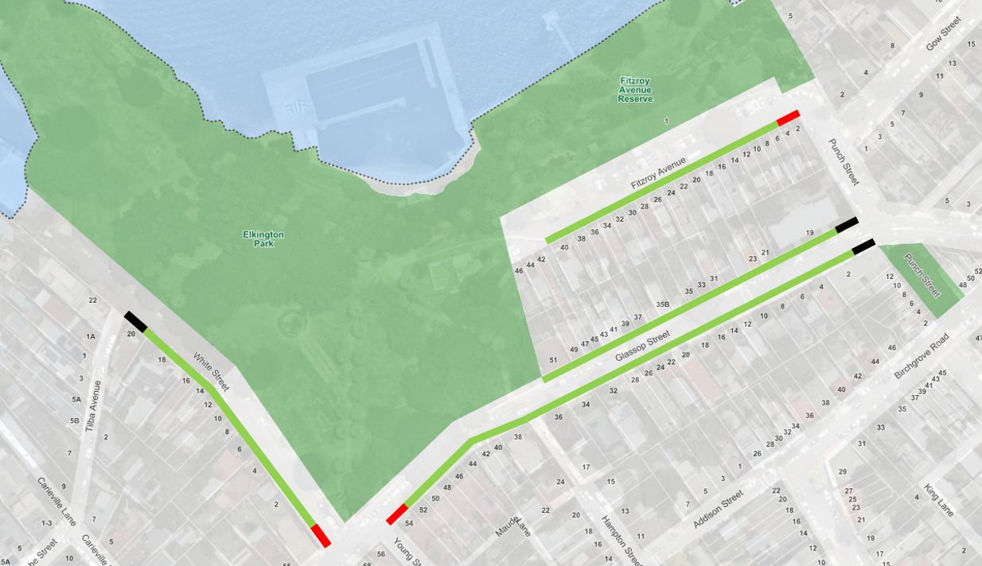
Existing ‘No Stopping’ Zone
Proposed 10m ‘No Stopping’ Zone
Proposed ‘2P 8am-10pm Permit Holders Excepted Area B1’

