

Pesticide Use Notification Plan 2025-2028

V1

Title | Pesticide Use Notification Plan 2025-2028
Summary | This plan provides a summary of Council's legislative obligations for pesticide use and the notification procedures for Council staff to implement.
Document Type | Plan
Relevant Strategic Plan Objective | - Strategic Direction 1: An ecologically sustainable Inner West  - Strategic Direction 2: Liveable, connected neighbourhoods and transport.  - Strategic Direction 3: Creative communities and a strong economy  - Strategic Direction 4: Healthy, resilient and caring communities  - Strategic Direction 5: Progressive responsive and effective civic leadership.
Legislative Reference | - Pesticides Act 199  - Pesticide Regulation 2017
Related Council Documents | - Code of Conduct  - Weed Management Policy
Version Control | See last page

Contents
Contents 3
1. Introduction 4
2. Public places Covered by this plan 4
3. Notification Arrangements 7
4. How and when notice of pesticide use will be provided 8
5. What information will be provided 11
6. How the community will be informed of this plan 12
7. Breaches of this Guideline/Procedure 12
8. Administrative Changes 12
9. Version Control – Guideline/Procedure History 13
10. Appendix 1. Map of Inner West Council 14

Introduction
This pesticide use notification plan has been prepared in accordance with the requirements of the Pesticides Regulation 2017 (the Regulation) under the Pesticides Act 1999.
The aim of this plan is to meet the community's general right to know about pesticide applications made to outdoor public places that are owned or controlled by public authorities. The Plan does not apply to outdoor public places that are not owned or controlled by Council.
The plan allows members of the community to avoid contact with pesticides, if they wish. Council ensures that pesticides are applied to public places in a safe and responsible manner, minimising harm to the community and / or the environment. In addition, Council's application of pesticides is in accordance with the relevant material safety data sheets.
The plan sets out how Inner West Council will notify members of the community of pesticide applications it makes, or allows to be made, to public places.
The plan describes:
- What public places are covered by the plan
- Who regularly uses these public places and an estimate of the level of use
- How and when Council will provide the community with information about its pesticide applications in public spaces (i.e. what notification arrangements will be used)
- How the community can access this plan and get more information about Council's notification arrangements
- How future reviews of the plan will be conducted
- Contact details for anyone wishing to discuss this plan with Council.
The majority of pesticide use by Council consists of applying herbicides for weed control. Programmed herbicide use on sports fields range from 1-2 applications per year for general park turf surfaces and up to 8 times per year for public thoroughfares. All other herbicides and insecticides used for the control of weeds and insects in Councils parks are as required and are generally less than four times a year. Bait insecticides and rodenticides are used for termite, ant and rodent control to protect structures and public safety whenever this is.

Public places Covered by this plan
Inner West Council proposes to use or allow the use of pesticides in the following categories of outdoor public places that it owns or controls within its LGA area boundaries.
- Public gardens and parks
- Sporting fields and ovals
- Road verges, nature-strips, footpaths
- Laneways, pathways, roadways, public accessible easements, foreshore paved areas
- Aquatic centres (building exteriors and grounds)
- Other public facilities (building exteriors & interiors)
Inner West Council's estimate of the level of community use, regular user groups, and type of pesticide use in each of these categories of public places is summarized in the following table. For the purpose of this plan, spot pesticide use refers to small applications using handheld equipment while broad scale applications typically involve the use of covered boom spray equipment on large open space areas.

Public Places | Regular User Groups | Level of  Use of Public Place | Type of Pesticide Use
- Public Gardens and Parks  - (EXCLUDES playground equipment areas within parks) | School groups  Sporting groups and associations  Fitness and exercise groups  Families with children  Tourists and visitors to the area  General recreational users  ( e.g. joggers, dog  walkers) | High | Spot herbicides  Spot insecticides  Spot turf growth regulators  Broadside selective herbicides  Broadside non selective herbicide  Bait rodenticides  Nematicides
- Sporting Fields and Ovals | Sporting groups and associations  School sports groups  General recreational users (e.g. joggers, dog walkers) | High | Spot herbicides  Spot insecticides  Spot turf growth Regulators  Spot fungicide  Broad scale fungicide  Nematicides
- Road verges, Nature- strips, Footpaths | Local residents  Tourist and visitors to  the area  People who work in the area  Shoppers | Medium to high | Spot herbicides  Broad scale selective herbicide  Broad scale non- selective herbicide  Soot termiticides
- Laneways, pathways, roadways, public accessible easements, foreshore paved areas | Local residents  People who work in  the area  Tourists and visitors to the area | Medium to high | Spot herbicides  Broad scale non- Selective herbicides  Spot algaecide’s  Sport turf growth regulators
- Aquatic centres (building exteriors/interior) | Local residents  People who work in the area  School groups  Visitors | High | Spot herbicides  Spot insecticides  Spot algaecide’s  Broad scale selective herbicide  Broad scale non-  selective herbicide
- Other public facilities (building exteriors/interior) | Library users  Young children and Their Carers (childcare facilities)  Parent groups, playgroups community  associations  Visitors  General members of the public | High | Spot herbicides  Spot insecticides  Spot termiticides  Spot rodenticides

Notification Arrangements
This section of the plan describes how and when Inner West Council will l provide notice of pesticide use in public places, including special measures for sensitive places that are adjacent to public places, arrangements for emergency pesticide applications and circumstances where notice will not be given.
These notification requirements are based on Inner West Council's assessment of:
- The visitation rates and trends for the public places where pesticides may be applied
- The likelihood that regular users of the public space may be particularly sensitive to pesticides (e.g. young children, sick, pregnant, or elderly people)
- The possibility of direct contact with pesticides due to the activities commonly undertaken at the various types of public spaces (such as sporting facilities involving contact with the ground.
- The type of pesticide used.
Notice of pesticide use will be provided by one or a combination of:
- Signs
- Notice within a local community newspaper
- Letters
- Phone contact and/or Fax/email
- Letterbox drops and/or door knocking
- Inner West Council's web page
Council will also allow members of the community and organisations to have their details placed on a register which would allow them to be notified of certain types of pesticide uses in specific places or circumstances, as described in this section of the plan.
Inner West Council (or its lessees) uses small quantities of some pesticides that are widely available in retail outlets and ordinarily used for domestic purposes. An example of such use is the control of woody weeds in park reserves using small quantities of glyphosate herbicide. Council does not intend to provide notice for such pesticide applications other than by way of this description in this plan. However, operators applying these pesticides will make available general product details at the place and time of application in the event that members of the community require further information.

How and when notice of pesticide use will be provided
The notification arrangements described below will apply to the following public place categories owned or controlled by council within the Inner West local government area (LGA):
- Public Gardens & Parks (EXCLUDES playground equipment areas within parks)
- Sporting fields & ovals
- Road verges, Nature-strips, Footpaths
- Laneways, pathways, roadways, public assessable easements, foreshore paved areas
- Aquatic centres (building exteriors and grounds)
- Other public facilities
In these public places, signs will be provided for the general community near the application area or at the main entrances prior to application for the following pesticide uses:
- Spot turf growth regulators
- Broad scale turf growth regulators
- Broad scale selective herbicides
- Broad scale non-selective herbicides
- Spot insecticides
- Broad scale insecticides
- Spot fungicide
- Broad scale fungicide
- Bait rodenticides
Council conducts an annual broad scale selective herbicide program to control broadleaf weeds within turf areas of parks and sports fields. Additional notice of this pesticide application program will be provided to the general community within a local community newspaper and on council's website at least seven days prior to the first application (first park sprayed).
Parks and public gardens
Signs to give the general community notice of the proposed pesticide use will be provided near the application area prior to application for the following pesticides uses:
- Broad scale herbicides
- Broad scale insecticides
- Fungicides
- Termiticides
Notice will not be given for the following pesticide applications:
- Spraying of glyphosate using a hand spray bottle, wand, or spray lance
- Spot insecticides
- Bait rodenticides or ant control
Note: this EXCLUDES playground equipment areas within parks. Pesticides will not be utilised in playground equipment areas within parks. In these area, weed management is undertaken by steam weeding, mechanical weeding or hand weeding.
Sporting grounds
In these public spaces, signs to give the general community notice of the proposed pesticide use will be provided near the application area prior to application for the following pesticides uses:
- Broad scale herbicides
- Broad scale insecticides
- Fungicides
Sporting groups that register interest with Council for the purpose will also have notice of the above pesticide use faxed or emailed to the group’s secretary and/or public officer prior to the application.
Notice will not be given for the following pesticide applications:
- Spraying of glyphosate using a hand spray bottle, wand, or spray lance
- Spot insecticides
- Bait ant control
Outdoor public thoroughfares and certain easements accessible to the public
The notification arrangements described below will apply to the following public place categories owned or controlled by council within the Inner West LGA:
- Road verges
- Nature-strips
- Footpaths
- Laneways
- Roadways
- Publicly accessible easements
- Foreshore paved areas
In these public places, signs will be provided for the general community at the place and for the duration of application only for the following pesticide uses:
- Broad scale herbicides
- Spot turf growth regulators
- Spot Algaecides
Notice will not be given for the following pesticide applications:
- Spot herbicides
- Spot insecticides
- Bait rodenticides or ant control
Aquatic centre (building exteriors and grounds)
Notification of pesticide use within Inner West Aquatic Centres shall consist of signs placed at the entrance prior to application for the following pesticide uses:
- Broad scale herbicides
- Broad scale insecticides
- Broad scale turf growth regulators
- Fungicides
- Termiticides
Notice will not be given for the following pesticide applications:
- Spot herbicides
- Spot insecticides
- Bait rodenticides or ant control
Other public facilities (building exteriors)
Information for the general community on the following types of pesticide use shall consist of signs posted near the entrances to properties beforehand:
- Broad scale herbicides
- Broad scale insecticides
- Fungicides
- Termiticides
Notice will not be given for the following pesticide applications:
- Spot herbicides
- Spot insecticides
- Bait rodenticides or ant control
Special measures for sensitive places
Clause 18 of the Pesticides Regulation 2009 defines a sensitive place to be any:
- School or pre-school
- Kindergarten
- Childcare centre
- Hospital
- Community health centre
- Nursing home
- Any other place declared to be a sensitive place by the Environment
- Protection Authority (now a part of the Department of Environment and Conservation).
Special notification measures will exist for programmed pesticide use in public out door areas adjacent to all sensitive places. The occupiers will be provided prior targeted notice by phone, email, or letterbox drop (whichever is most practicable) for the following pesticide uses:
- Spot turf growth regulators
- Broad scale turf growth regulators
- Broad scale herbicides
- Spot insecticides
- Broad scale insecticides
- Spot fungicide
- Broad scale fungicide
- Spot termiticides
- Spot Algaecides
- Bait rodenticides or ant control
Notification of emergency pesticide applications
In cases where emergency pesticide applications in public places are required to deal with biting or dangerous pests such as wasps, bees, venomous spiders, fleas, bird mites or rodents (that pose an immediate health hazard), Council will, where possible, display signs at the place and time of the pesticide application. Council will also ensure that the operator applying the pesticide provides verbal notice to the public in the vicinity of the application.
Pesticide contractors and lessees of public places
Where Council uses contractors to apply pesticides on its behalf, Council will ensure that notification is made in accordance with the notification requirements of this plan.
Where persons or organisations hold a lease on publicly accessible Council land that remains a public place and if they use pesticides in this area, Council will require community notification of any pesticide application in accordance with the requirements of this plan. In this instance, the notification requirements will be the responsibility of the lessee.

What information will be provided
In accordance with clause 20(h) of the Pesticides Regulation, notice of pesticide uses will include the following information:
- The full product name of the pesticide to be used, and
- The purpose of the use, clearly setting out what pest or pests are being treated,
- The proposed date/s or date range of the pesticide use, and
- The places where the pesticide is to be used, and
- Contact telephone number and email address of the Council l officer who people can contact to discuss the notice, and
- Any warnings regarding re-entry to or use of the place, if specified on the pesticide product label or the APVMA¹ permit.
- Signs will be of a standardized design that will be easily recognisable to the public and workers.
¹ The Australian Pesticides and Veterinary Medicines Authority (APVMA) , the national government body responsible for assessing and registering (or otherwise approving) all pesticide products in Australia and for their regulation up to and including the point of retail sale.

How the community will be informed of this plan
Inner West Council will advise residents of this plan and its contents by:
Placing a copy of the plan on its website, www.innerwest.nsw.gov.au

Breaches of this Guideline/Procedure
Breaches of this Guideline/Procedure may result in an investigation of the alleged breach in line with relevant Council policies including the Model Code of Conduct.
Any alleged criminal offence or allegation of corrupt conduct will be referred to the relevant external agency.

Administrative Changes
From time-to-time circumstances may change leading to the need for minor administrative changes to this document. Where an update does not materially alter this document, such a change may be made including branding, Council Officer titles or department changes and legislative name or title changes are considered minor in nature and not required to be formally endorsed.

Version Control – Guideline/Procedure History
This Guideline/Procedure will be formally reviewed every three years, from the date of approval or as required, in conjunction with the overarching Policy or Operational Management Standard.
Governance use only:
Document | Pesticide Notification Plan | Uncontrolled Copy When Printed
Custodian | Senior Manager Operations Parks & Streetscapes | Version # | Version 1
Approved By | Council | ECM Document # | xxxxxxxx
Next Review Date | xxxx

Amended by | Changes made | Date
Trees Parks and Streetscapes | New Guideline | 2019

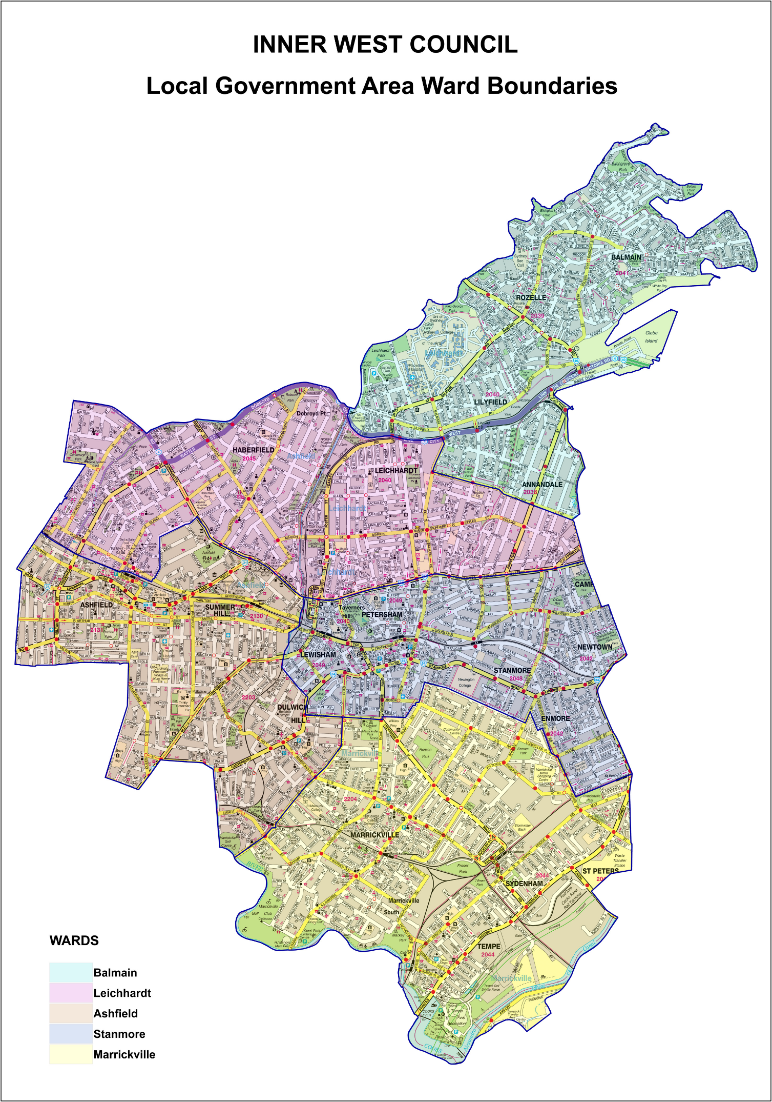
Appendix 1. Map of Inner West Council

